Logo Identity Design Survey

Completing this survey will help Lynn Media Group understand the essentials of your business. For new businesses, the survey defines what Lynn Media Group needs in order to begin project work on a new logo identity design.

Name, Tagline and Domain Name
When it comes to logo identity design, just about everything is in the literal name. Providing the name and intended tagline helps determine the shape, style and overall essence of the new identity design. Please also list the existing or intended domain name.

<<Please insert here>>

Mission Statement
A mission statement provides the intention and often the symbolic reference behind a robust and meaningful corporate identity. Please provide your company's mission statement below:

<<Please insert here>>

Value Proposition (User Benefits)
The value proposition of your business is essential to know when designing a logo identity. This statement, or list of user benefits, also serves as a prioritizing tool for design choices.

<<Please insert here>>

Target Audience(s)
A central step in fulfilling a powerful logo design is to understand the identity's primary and secondary target audiences. Clarifying these audiences also helps prioritize design choices.

<<Please insert here>>

Distinctions
List several key distinctions about your product or company. These distinctions -- what differs it from its competitors -- enable Lynn Media Group to make design choices that emphasize them.

<<Please insert here>>

Competitors
Along these same lines, please list the central competitors in your market space. It is critical to know how best to distinguish your brand amongst a field of competitors.

<<Please insert here>>

First Impression Keywords
What primary first impressions would you like a person or business to receive upon viewing this corporate identity in 8 seconds or less? Some examples might be "trustworthy" or "innovative."

<<Please insert here>>

Logo identity type

What type of logo design do you want? The range of choices include:

- Wordmark, a type logo only (Google)
- Wordmark with a graphic tie-in (Intel)
- Wordmark with a simple break away mark that can be used without supporting text (Target)
- Combination of a wordmark and custom illustration (Starbucks)

It's okay if you don't know as well, simply write: "I don't know yet."
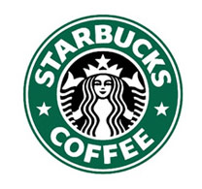
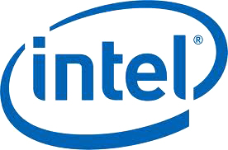
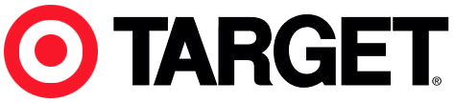
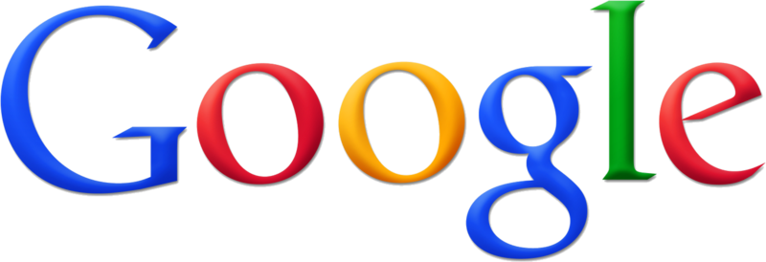

<<Please insert here>>

Usage
Consider the many ways in which your logo identity will be used and identify the most important mediums. For instance, digital -- websites, iPhones, iPads -- or print. Also, will the identity be used as a cobrand or an add-on component within future brands, such as a single title within a book series?

Please expand upon usage below:

<<Please insert here>>

